SIMATS ENGINEERING
ASSESSMENT TOOL 2

COURSE NAME: Database Management Systems
COURSE CODE: CSA05

CO5: Implement database operations using query processing, optimization, and transaction management to ensure consistency and reliability. (BL3, BL4)

Activity Tool : Pseudocode Writing Task (Algorithm Design) (Medium)
Assessment Tool Weightage: 35%

Dr

QUESTIONS Total Marks: 50
Q.No | Question | Bloom's Level | Marks
1 | Write pseudocode for the complete query processing pipeline: from SQL input through parsing, optimization, and execution to result output. | BL3 – Apply | 5
2 | Design a pseudocode algorithm for cost-based query optimization that estimates and compares I/O costs for different join orderings. | BL4 – Analyze | 5
3 | Write pseudocode for the Nested Loop Join algorithm and analyze its time complexity in terms of buffer pages and tuple counts. | BL3 – Apply | 5
4 | Write a pseudocode algorithm to detect deadlocks in a transaction system using a Wait-For Graph (WFG) cycle detection. | BL4 – Analyze | 5
5 | Design a pseudocode for the Basic Two-Phase Locking protocol including lock request, grant, wait, and release phases. | BL3 – Apply | 5
6 | Write pseudocode for timestamp-based concurrency control using Thomas' Write Rule for handling conflicting read/write operations. | BL4 – Analyze | 5
7 | Write a pseudocode algorithm for the ARIES (Algorithm for Recovery and Isolation Exploiting Semantics) recovery technique with Analysis, Redo, and Undo phases. | BL3 – Apply | 5
8 | Design pseudocode for Shadow Paging recovery: maintain current and shadow page tables and roll back on failure. | BL3 – Apply | 5
9 | Write a pseudocode for Immediate Update recovery using UNDO/REDO log processing after a system crash. | BL3 – Apply | 5
10 | Write pseudocode for a database connectivity manager that handles connection pooling, query execution, and exception rollback. | BL4 – Analyze | 5

Code of Conduct:

I NITTHYENDREN JS 192421180 certify that this submission is my original work and that I have adhered to the guidelines specified for this assessment.
I understand that any violation of academic integrity rules will result in disciplinary action.

Signature of the student:
Nitthyendren JS

RUBRICS FOR CALCULATION:

Criteria | Weightage | Level 4 – Exemplary | Level 3 – Proficient | Level 2 – Developing | Level 1 – Beginning
Problem Understanding | 20% | Identifies all inputs, outputs, constraints accurately | Minor missing elements | Partial understanding | Incorrect interpretation
Algorithm Design | 30% | Complete, correct, and logically sound solution | Minor logical gaps | Partially correct logic | Incorrect approach
Use of Control Structures | 20% | Efficient and appropriate use of loops, conditions, functions/modules | Minor inefficiencies | Limited or basic usage | Incorrect or missing constructs
Pseudocode Structure | 10% | Well-structured, clear, consistent format, easy to follow | Mostly clear with minor issues | Difficult to follow in parts | Poorly structured and unclear
Completeness | 20% | Handles all cases; optimized approach | Handles most cases; reasonable efficiency | Handles basic cases only | Incomplete or inefficient

ANSWERS

Q1. Complete Query Processing Pipeline — 5 Marks
Inputs / Outputs / Constraints
Input: raw SQL query string. Output: result tuples returned to the user. Constraint: each stage must only pass a semantically valid, progressively lower-level representation to the next.
Pseudocode
FUNCTION processQuery(sqlText)

// Stage 1: Parsing
tokens = lexicalScan(sqlText)
parseTree = parse(tokens) // syntax check
IF parseTree is INVALID THEN
RETURN error("Syntax error")

// Stage 2: Semantic validation / translation
IF NOT validateAgainstSchema(parseTree) THEN
RETURN error("Unknown table/column")
relAlgebraTree = translateToRelationalAlgebra(parseTree)

// Stage 3: Heuristic (rule-based) optimization
relAlgebraTree = pushDownSelections(relAlgebraTree)
relAlgebraTree = pushDownProjections(relAlgebraTree)

// Stage 4: Cost-based optimization
candidatePlans = generateAlternativePlans(relAlgebraTree)
bestPlan = MIN_COST_PLAN in candidatePlans // see Q2

// Stage 5: Execution
executionPlan = compileToExecutablePlan(bestPlan)
resultSet = execute(executionPlan)

// Stage 6: Output
RETURN resultSet
Analysis: each stage's OUTPUT becomes the next stage's INPUT (tokens -> parse tree -> relational-algebra tree -> optimized tree -> executable plan -> tuples) — this staged pipeline is exactly how real query processors (e.g. PostgreSQL, MySQL) are structured.

Q2. Cost-Based Join-Ordering Optimization — 5 Marks
Inputs / Outputs / Constraints
Input: a set of relations to join, with tuple counts and page sizes. Output: the join order with minimum ESTIMATED I/O cost. Constraint: must consider every valid join ORDER (not just adjacent pairs) since join is associative/commutative.
Pseudocode (dynamic-programming join enumeration)
FUNCTION costBasedOptimize(relations[])

n = length(relations)
bestPlan = MAP() // bestPlan[subset] = (plan, cost)

// Base case: cost of accessing each single relation
FOR each relation R in relations:
bestPlan[{R}] = (scanPlan(R), pages(R))

// Build up plans for larger subsets of relations
FOR size = 2 TO n:
FOR each subset S of relations WITH |S| == size:
bestCost = INFINITY
FOR each way to split S into S1, S2 (S1 union S2 = S):
joinCost = bestPlan[S1].cost + bestPlan[S2].cost
+ estimateJoinCost(bestPlan[S1], bestPlan[S2])
IF joinCost < bestCost THEN
bestCost = joinCost
bestPlan[S] = (joinPlan(S1, S2), joinCost)

RETURN bestPlan[{all relations}]

FUNCTION estimateJoinCost(planA, planB)
RETURN MIN(
nestedLoopCost(planA, planB),
hashJoinCost(planA, planB),
sortMergeCost(planA, planB)
)
Consideration | Why it matters
Subset enumeration | Ensures ALL join orders are compared, not just left-deep default
Cost re-use (memoization) | Avoids recomputing the same sub-join's cost repeatedly
Multiple join-method costs | The cheapest join order can still use the WRONG join algorithm if only one method's formula is checked

Q3. Nested Loop Join — Pseudocode and Complexity Analysis — 5 Marks
Pseudocode (Block Nested-Loop Join, buffer-aware)
FUNCTION blockNestedLoopJoin(outerRel, innerRel, condition, B)
// B = total buffer pages available; (B-2) reserved for outer blocks,
// 1 for inner scan, 1 for output

result = empty list
FOR each chunk of (B-2) pages of outerRel:
load chunk into memory
FOR each page p of innerRel:
FOR each tuple t_out in chunk:
FOR each tuple t_in in p:
IF condition(t_out, t_in) THEN
result.append(combine(t_out, t_in))
RETURN result
Time / I/O complexity analysis
Parameter | Meaning
M | pages of outer relation
N | pages of inner relation
B | buffer pages available

I/O Cost = M + ceil( M / (B-2) ) x N
Analysis: the OUTER relation is read exactly once (M pages); the INNER relation is re-read once per OUTER CHUNK, and the number of chunks is ceil(M/(B-2)) — so choosing the SMALLER relation as the outer table directly minimizes total I/O, since it minimizes the number of times the (potentially larger) inner relation must be re-scanned.

Q4. Deadlock Detection via Wait-For Graph Cycle Detection — 5 Marks
Diagram — example cycle
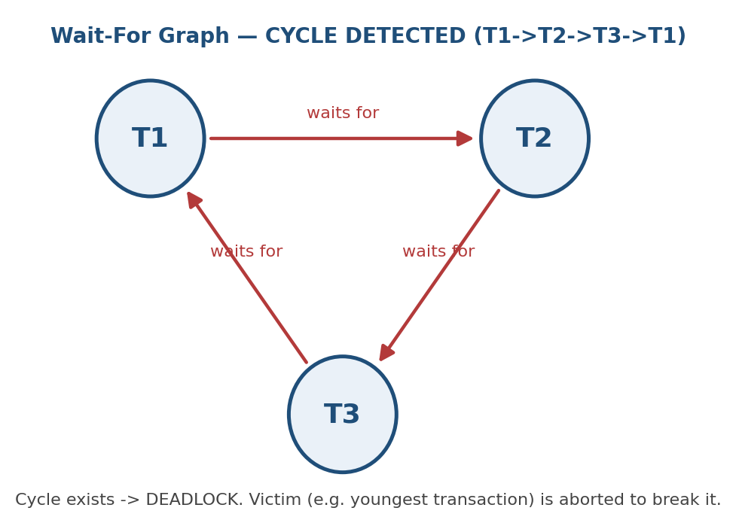

Pseudocode (DFS-based cycle detection)
FUNCTION detectDeadlock(WFG) // WFG = {transaction -> list of transactions it waits for}

visited = SET(), inStack = SET()

FOR each transaction T in WFG.nodes:
IF T NOT IN visited:
IF hasCycleDFS(T, WFG, visited, inStack) THEN
RETURN "DEADLOCK DETECTED"
RETURN "NO DEADLOCK"

FUNCTION hasCycleDFS(node, WFG, visited, inStack)
visited.add(node)
inStack.add(node)

FOR each neighbor IN WFG[node]: // node waits for neighbor
IF neighbor IN inStack THEN
RETURN true // back edge -> cycle found
IF neighbor NOT IN visited:
IF hasCycleDFS(neighbor, WFG, visited, inStack) THEN
RETURN true

inStack.remove(node) // backtrack
RETURN false
Analysis: a back-edge found during DFS (reaching a node still on the current recursion stack) is exactly a cycle in the Wait-For Graph, which corresponds one-to-one with a real deadlock — this is why cycle detection is the standard deadlock DETECTION strategy, as opposed to Wait-Die/Wound-Wait (Q6 of AT1) which PREVENT deadlocks before they occur.

Q5. Basic Two-Phase Locking — Request / Grant / Wait / Release — 5 Marks
FUNCTION requestLock(transaction T, item X, mode) // mode = SHARED or EXCLUSIVE

IF T.phase == SHRINKING THEN
ABORT T // 2PL rule: no new locks once shrinking begins

IF isCompatible(mode, currentLocksOn(X)) THEN
grantLock(T, X, mode)
T.locksHeld.add(X)
T.phase = GROWING
ELSE
addToWaitQueue(T, X, mode)
T.state = WAITING
// periodically re-check compatibility, or be woken on release

FUNCTION releaseLock(transaction T, item X)
removeLock(T, X)
T.phase = SHRINKING // first release moves T into shrinking phase
wakeWaitingTransactions(X) // re-check the wait queue for X

FUNCTION isCompatible(requestedMode, existingLocks)
IF existingLocks is empty THEN RETURN true
IF requestedMode == SHARED AND all existingLocks == SHARED THEN RETURN true
RETURN false // any EXCLUSIVE lock conflicts with anything
Analysis: the single line 'IF T.phase == SHRINKING THEN ABORT' is what enforces the entire 2PL guarantee — once a transaction releases even one lock, it is forbidden from acquiring any new lock, which is precisely the growing/shrinking phase split that makes 2PL schedules provably conflict-serializable.

Q6. Timestamp-Based Concurrency Control with Thomas' Write Rule — 5 Marks
FUNCTION handleRead(transaction T, item X)
IF TS(T) < W_TS(X) THEN
ABORT T; restart T with a NEW timestamp // T is too old to read X safely
ELSE
perform read
R_TS(X) = MAX(R_TS(X), TS(T))

FUNCTION handleWrite(transaction T, item X)
IF TS(T) < R_TS(X) THEN
ABORT T; restart T with a NEW timestamp // a younger txn already read X

ELSE IF TS(T) < W_TS(X) THEN
// Thomas' Write Rule: a NEWER write already happened -- this write is obsolete
IGNORE the write (do NOT abort T, simply skip applying it)

ELSE
perform write
W_TS(X) = TS(T)
Analysis: the key difference from basic timestamp ordering is the middle branch — instead of aborting T when TS(T) < W_TS(X), Thomas' Write Rule simply DISCARDS the obsolete write (since a later write has already superseded it), allowing T to continue instead of restarting — this reduces unnecessary aborts while still preserving a serializable-equivalent outcome.

Q7. ARIES Recovery — Analysis, Redo, Undo Phases — 5 Marks
Overview of the three phases
Phase | Direction | Purpose
Analysis | Forward, from last checkpoint | Determine dirty pages and active (loser) transactions at crash time
Redo | Forward, from earliest relevant LSN | Repeat history: reapply ALL logged updates (committed or not) to restore the exact pre-crash state
Undo | Backward | Roll back only the LOSER transactions' updates, using compensation log records (CLRs)

Pseudocode
FUNCTION ariesRecovery(log, lastCheckpoint)

// ---- Phase 1: ANALYSIS ----
dirtyPageTable = lastCheckpoint.dirtyPageTable
transactionTable = lastCheckpoint.transactionTable
FOR each logRecord FROM lastCheckpoint TO end of log:
IF logRecord.type == UPDATE THEN
IF logRecord.page NOT IN dirtyPageTable:
dirtyPageTable[logRecord.page] = logRecord.LSN
transactionTable[logRecord.txnId] = ACTIVE
IF logRecord.type == COMMIT THEN
transactionTable[logRecord.txnId] = COMMITTED
losers = { t IN transactionTable : t.status != COMMITTED }

// ---- Phase 2: REDO ----
startLSN = MIN(dirtyPageTable.values())
FOR each logRecord FROM startLSN TO end of log:
IF logRecord.type == UPDATE
AND logRecord.page.LSN < logRecord.LSN THEN
reapply(logRecord) // repeat history, even for losers

// ---- Phase 3: UNDO ----
toUndo = collect all UPDATE records belonging to losers
FOR each logRecord IN toUndo, IN REVERSE LSN ORDER:
undo(logRecord)
writeCompensationLogRecord(logRecord) // CLR: makes undo itself crash-safe
RETURN "Recovery complete"
Analysis: ARIES's defining idea is 'repeat history' — REDO reapplies EVERY update (including losers') before UNDO even begins, which sounds wasteful but massively simplifies correctness reasoning; UNDO then only needs to worry about losers, and CLRs guarantee the UNDO phase itself survives a second crash without ever redoing an undo.

Q8. Shadow Paging Recovery — 5 Marks
FUNCTION shadowPagingWrite(transaction T, pageId, newData)

IF T.currentPageTable[pageId] == T.shadowPageTable[pageId] THEN
// page not yet copied for this transaction -- copy-on-write
newPageLocation = allocateNewDiskPage()
copy(T.currentPageTable[pageId] -> newPageLocation)
T.currentPageTable[pageId] = newPageLocation

write newData to T.currentPageTable[pageId] // shadow copy untouched

FUNCTION commit(transaction T)
flush all pages referenced by T.currentPageTable to disk
atomically overwrite: masterPageTable = T.currentPageTable // single pointer swap
T.shadowPageTable = T.currentPageTable // becomes new shadow

FUNCTION rollback(transaction T)
T.currentPageTable = T.shadowPageTable // simply discard all current-table changes
discard newly allocated pages // never referenced by masterPageTable, safe to free
Analysis: because every write goes to a NEW page location rather than overwriting the original, the OLD (shadow) page table always still points to a fully consistent pre-transaction database — rollback is therefore just 'forget the current table', requiring NO undo log at all. The trade-off is that commit's atomic pointer swap must be a single, carefully-guaranteed atomic disk operation.

Q9. Immediate Update Recovery — UNDO/REDO Log Processing — 5 Marks
FUNCTION immediateUpdateRecovery(log)

undoList = SET(), redoList = SET()

// Pass 1: scan the log to classify every transaction
FOR each logRecord IN log:
IF logRecord.type == START THEN
undoList.add(logRecord.txnId) // assume active until proven committed
IF logRecord.type == COMMIT THEN
undoList.remove(logRecord.txnId)
redoList.add(logRecord.txnId)

// Pass 2 (UNDO): scan log BACKWARD, undo every write by an undoList transaction
FOR each logRecord IN log, IN REVERSE ORDER:
IF logRecord.type == UPDATE AND logRecord.txnId IN undoList:
write(logRecord.item, logRecord.beforeImage)
IF logRecord.type == START AND logRecord.txnId IN undoList:
writeLog(<logRecord.txnId, ABORT>)

// Pass 3 (REDO): scan log FORWARD, redo every write by a redoList transaction
FOR each logRecord IN log, IN FORWARD ORDER:
IF logRecord.type == UPDATE AND logRecord.txnId IN redoList:
write(logRecord.item, logRecord.afterImage)

RETURN "Database restored to consistent state"
Analysis: UNDO must run BEFORE REDO and in REVERSE log order, because Immediate Update may have already written some uncommitted changes to disk — those must be rolled back to their before-images first; REDO then runs FORWARD to guarantee every committed transaction's effect is present, regardless of whether it reached disk before the crash.

Q10. Database Connectivity Manager — Pooling, Execution, Exception Rollback — 5 Marks
CLASS ConnectionPoolManager
pool = empty queue
maxSize = configuredLimit

FUNCTION initialize(size)
FOR i = 1 TO size:
pool.enqueue(createNewConnection())

FUNCTION acquireConnection()
IF pool is empty:
IF activeConnections < maxSize:
RETURN createNewConnection()
ELSE:
WAIT until a connection is released // bounded pool, avoid overload
conn = pool.dequeue()
conn.status = IN_USE
RETURN conn

FUNCTION releaseConnection(conn)
conn.status = IDLE
pool.enqueue(conn)
notifyWaitingThreads()

FUNCTION executeQuery(sqlText, params)
conn = acquireConnection()
TRY
conn.setAutoCommit(false)
stmt = conn.prepareStatement(sqlText)
bindParameters(stmt, params)
result = stmt.executeUpdateOrQuery()
conn.commit()
RETURN result
CATCH SQLException as ex:
conn.rollback() // undo partial work on failure
logError(ex)
RETURN error(ex)
FINALLY:
releaseConnection(conn) // ALWAYS return the connection, success or failure
Analysis: TRY/CATCH/FINALLY structures the exception-safety guarantee — rollback() runs on any SQLException (preventing partial writes from persisting), while FINALLY guarantees the connection is always returned to the pool, so a single query failure can never leak a connection and starve the pool over time.

